Assignment 4: Static Analysis Tool
Gabriel Wynne
1002184660
Part 1
Manual code review:
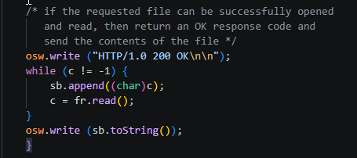
The response only sends HTTP/1.0 200 OK, this is a problem because it does not include headers so an XSS attack can occur

Spotbugs code review:
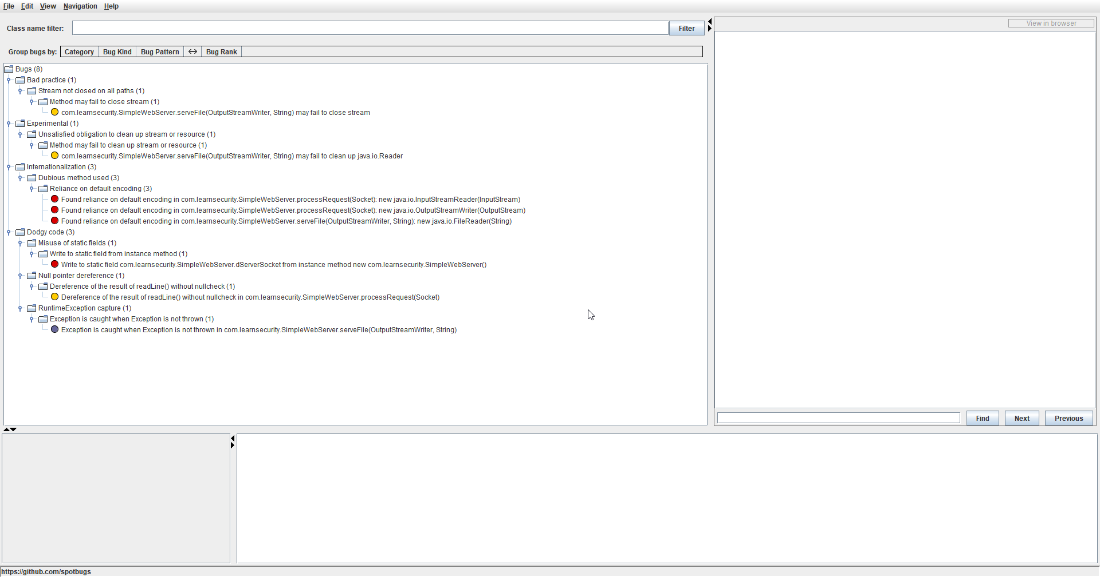
Different settings in SpotBugs were tested by enabling and disabling bug categories. Increasing sensitivity slightly increased the number of reported issues, while reducing it lowered the number of warnings. Due to the small size of the code, the overall difference in results was minimal.
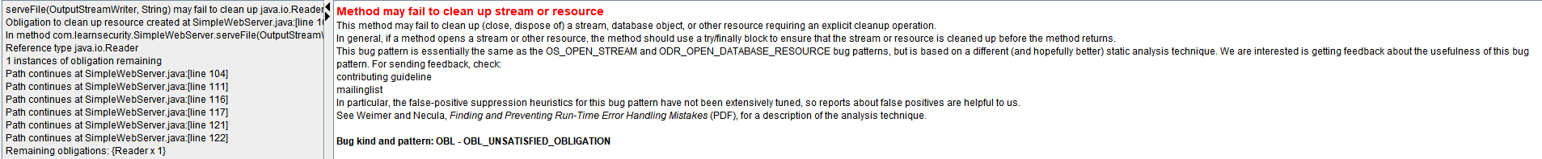
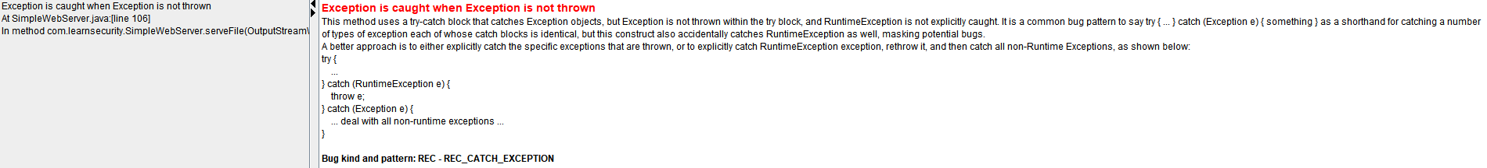
PMD Code review:
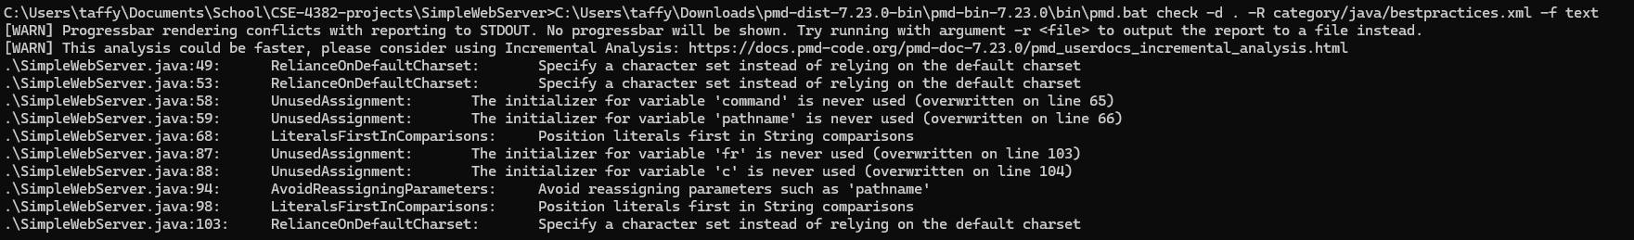
Different rule sets in PMD were tested. Enabling more rules increased the number of reported issues, while using fewer rules reduced them. Due to the small codebase, the overall differences were minor.

Part 2
Manual code review:
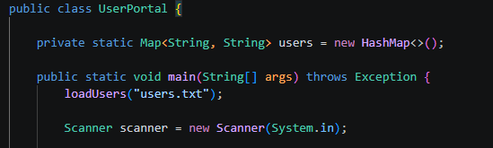
The problem here is if an attacker gets access to users.txt they will have full access to everyone’s information

SpotBugs code review:
